(this is one possible way to consolidate the plots, see the following pages for individual figures)
Prod vs Union Decline Prod vs Manuf Decline

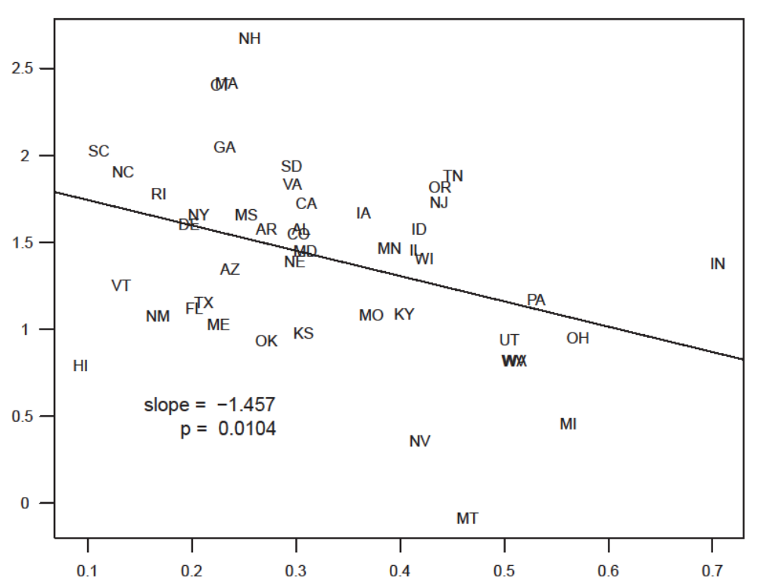
1964 - 2010
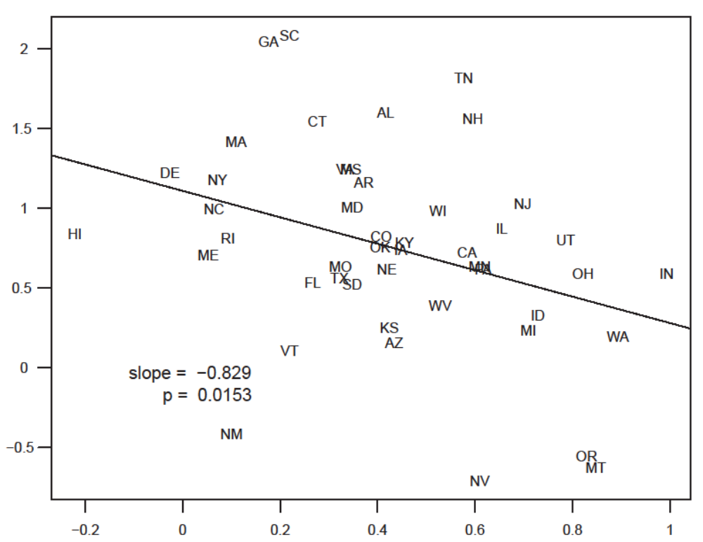
1964 - 1984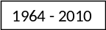84

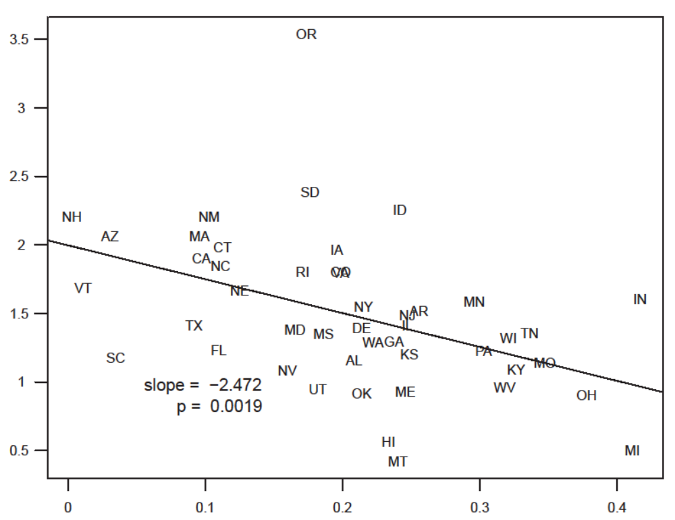
1985 - 201084
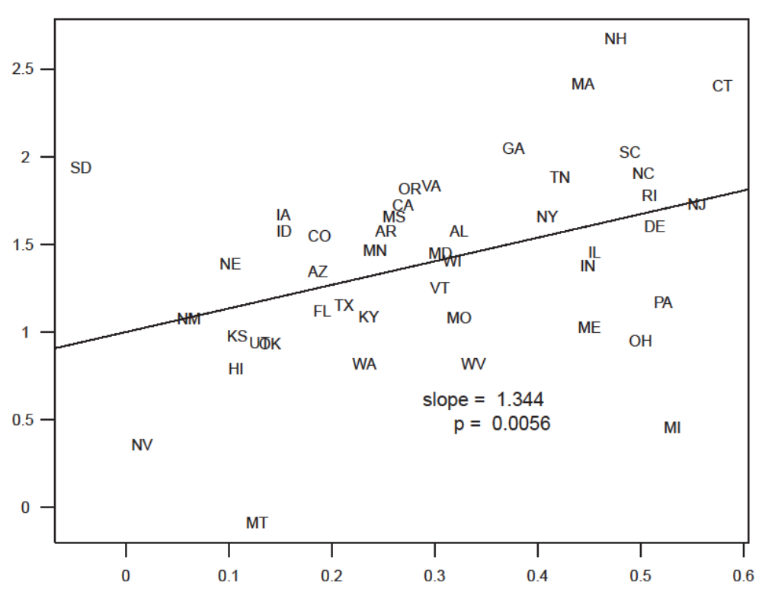
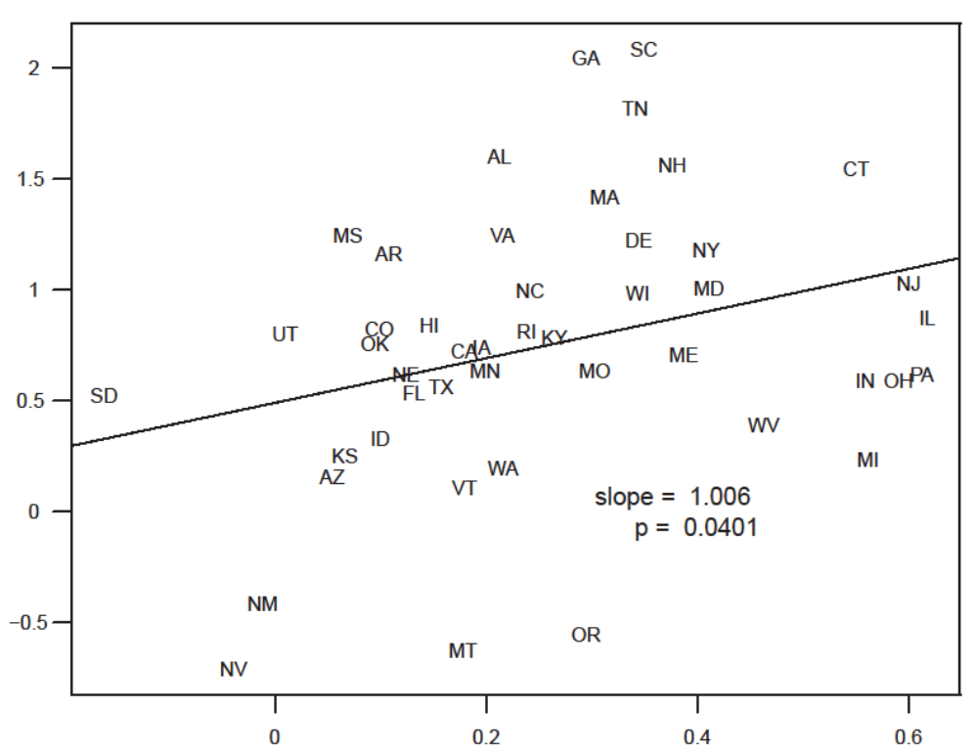

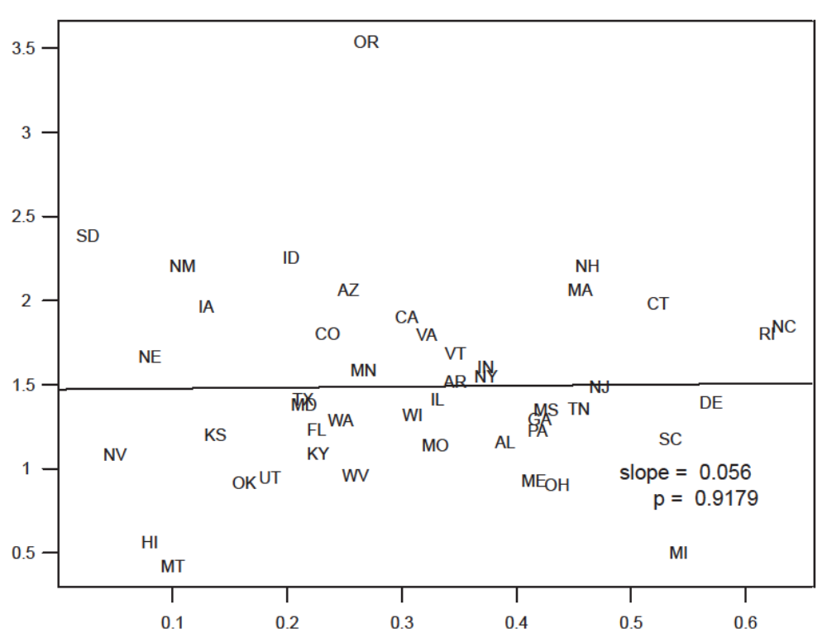

Notes: generalized notes go here
Sources: full sources go here
Figure: 1969 – 2010 Average annual % change in productivity vs average annual percent point decrease in union share

Notes: Excludes outlier states: Alaska, North Dakota, Louisiana and Wyoming. Data for each state from 1969-1971 is averaged to provide the initial productivity and union share values. Data for each state from 2008-2010 is averaged to provide the final productivity and union share values. The values in this figure are the difference between the final and initial values divided by 40, the number of years from the beginning of the period to the end (1970 to2009, due to the three year averages used for the final and initial values). Productivity is measured as RGDP/employed.

Sources: Total state/year employment: BEA SA27 and SA27N data. For RGDP and union share details, see (other section of report)

Figure: 1969 – 2010 Average annual % change in productivity vs average annual percent point change in manuf share…
Notes: Excludes outlier states: Alaska, North Dakota, Louisiana and Wyoming. Data for each state from 1969-1971 is averaged to provide the initial productivity and manufacturing share values. Data for each state from 2008-2010 is averaged to provide the final productivity and manufacturing share values. The values in this figure are the difference between the final and initial values divided by 40, the number of years from the beginning of the period to the end (1970 to2009, due to the three year averages used for the final and initial values).

Sources: Total state/year employment: (link to bea.gov source); for RGDP and manufacturing share details see (other section of report)

Figure: 1969 – 1984…union…

Notes:
Sources:

Figure: 1969 – 1984…manuf…

Notes:
Sources:

Figure: 1985 – 2010…union…

Notes:
Sources:

Figure: 1985 – 2010…manuf…

Notes:
Sources:

Regression summary of average annual % change in productivity as a function of percentage point decrease in union share:
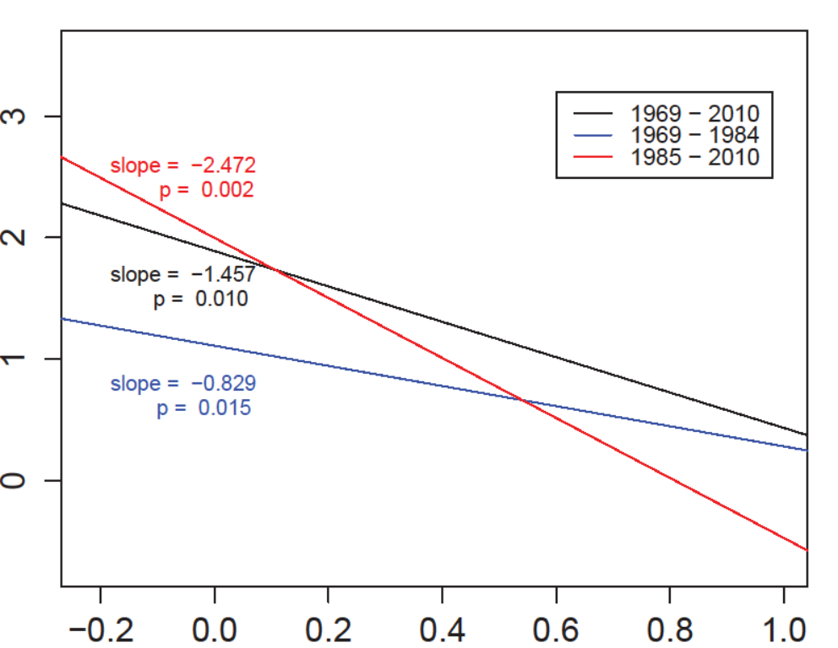

Regression summary of percentage point decrease in manufacturing share as a function of percentage point decrease in union share:
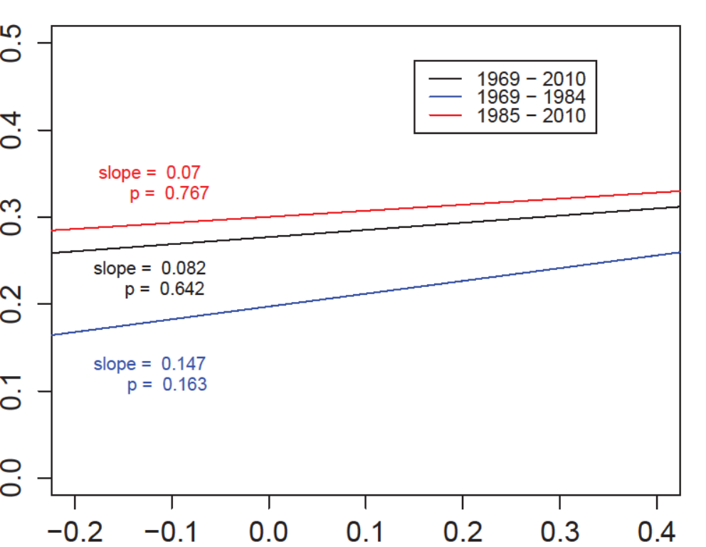

Bivariate regression table:
 | 1969 to 2010 |  |  |  | 1969 to 1984 |  |  |  | 1985 to 2010
avg annual %Δproductivity
Intercept |  | 1.491*** |  |  |  | 0.850*** |  |  |  | 1.959***
SE |  | 0.209 |  |  |  | 0.176 |  |  |  | 0.227
union share |  | -1.575*** |  |  |  | -1.021*** |  |  |  | -2.481***
SE |  | 0.489 |  |  |  | 0.3091 |  |  |  | 0.760
manuf share |  | 1.439*** |  |  |  | 1.310*** |  |  |  | 0.128
SE |  | 0.419 |  |  |  | 0.440 |  |  |  | 0.489
R² |  | 0.293 |  |  |  | 0.242 |  |  |  | 0.162

Notes: excludes out liers…methods…
Sources:
Summary statistics: (let me know how you prefer this table to be organized)
 |  |  | mean |  | sd |  | min |  | max
 | average annual:
1969 - 2010 | pct point union decrease |  | 0.329 |  | 0.138 |  | 0.093 |  | 0.705
1969 - 2010 | pct point manuf decrease |  | 0.304 |  | 0.161 |  | -0.044 |  | 0.580
1969 - 2010 | pct change in productivity |  | 1.409 |  | 0.538 |  | -0.085 |  | 2.672
1969 - 1984 | pct point union decrease |  | 0.430 |  | 0.269 |  | -0.221 |  | 0.993
1969 - 1984 | pct point manuf decrease |  | 0.261 |  | 0.189 |  | -0.162 |  | 0.618
1969 - 1984 | pct change in productivity |  | 0.752 |  | 0.626 |  | -0.709 |  | 2.082
1984 - 2010 | pct point union decrease |  | 0.206 |  | 0.100 |  | 0.003 |  | 0.417
1984 - 2010 | pct point manuf decrease |  | 0.315 |  | 0.156 |  | 0.026 |  | 0.633
1984 - 2010 | pct change in productivity |  | 1.489 |  | 0.558 |  | 0.422 |  | 3.537

